Eemil Aspholm

CT30A3370 Käyttöjärjestelmät ja systeemiohjelmointi

Viikkotehtävä 8.

1. I am using ubuntu version 20.04 through virtual box, and the default desktop environment is called Gnome. The default editor that gnome uses is called Gedit. Gedit can be used by typing command gedit to the terminal, or manually by opening the text editor by searching gedit/text editor from the desktop.
2. I was unable to test the command in assignment 2, so I had to test out ssh connection by setting up my own Github account and connecting it with my ubunutu.



Currently I am connected to my github and I am able to transfer data between my local and remote system (ubuntu / github).

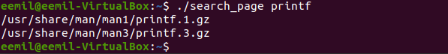



I also found that the script could be operated in the terminal, shown below:

